

OUR INTEGRATION PRESTIGIOUS BRANDS



**







F:\SDP - DI-BT DETA DETAIL-New HDD 21-06-2017\All Brand System\Logic\Pics\LR 601_files\logo.png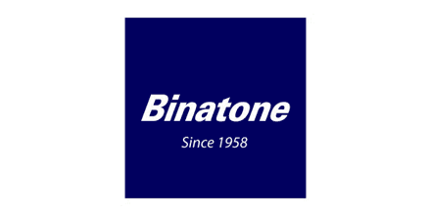Polycom Logo